**MSDS**

**INTRODUCTION**

 Material Safety Data Sheets, commonly called MSDS, is a very important document. Every workspace should have readily accessible MSDS for all the hazardous materials that are handled, stored there

First of all, the time to become familiar with a material's MSDS is before you begin using the material. Before procuring any hazardous material, you should obtain an advance copy of the MSDS to review the safety information before the order is placed. Once a material is brought into the workspace, everyone who uses it should review the MSDS. What if the material catches fire? Don't wait for an emergency to learn about material's hazardous properties! The MSDS specifies fire-fighting procedures for the material and never ignore this and don't run for it during an emergency.

             MSDS will also detail what personal protective equipment is required when using the material. It also lists condition to avoid when working with the material, such as heat and sparks. Also it tells what materials should not be brought into contact with the material and provides valuable information for storage and disposal of the material.

**MSDS HOME PAGE**

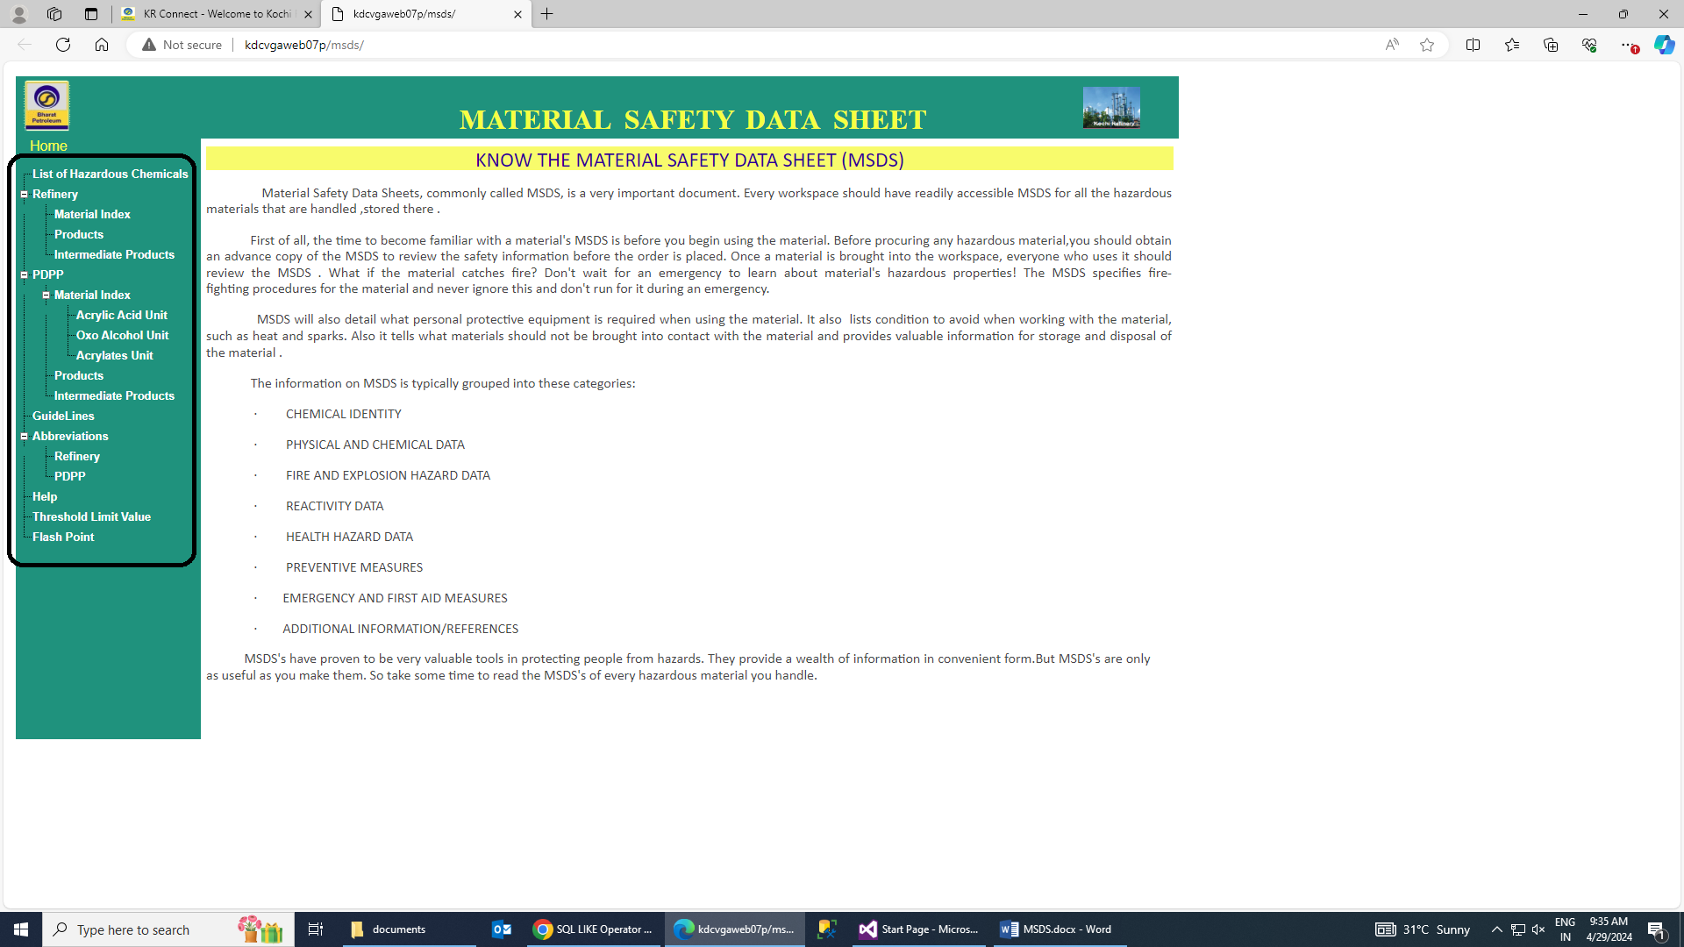

LIST OF HAZARDOUS CHEMICALS

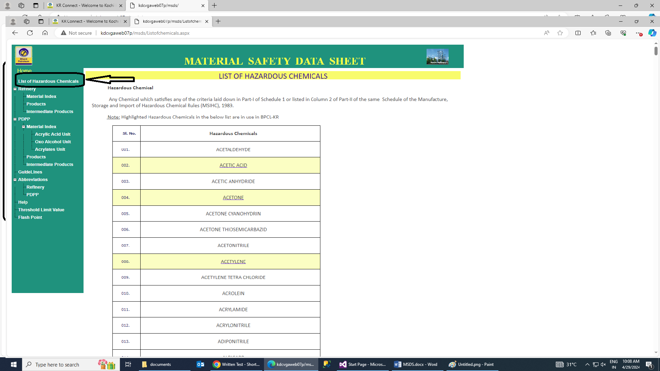

Fig.01

**REFINERY**

* MATERIAL INDEX
* PRODUCTS
* INTERMIDATE PRODUCTS

**MATERIAL INDEX**

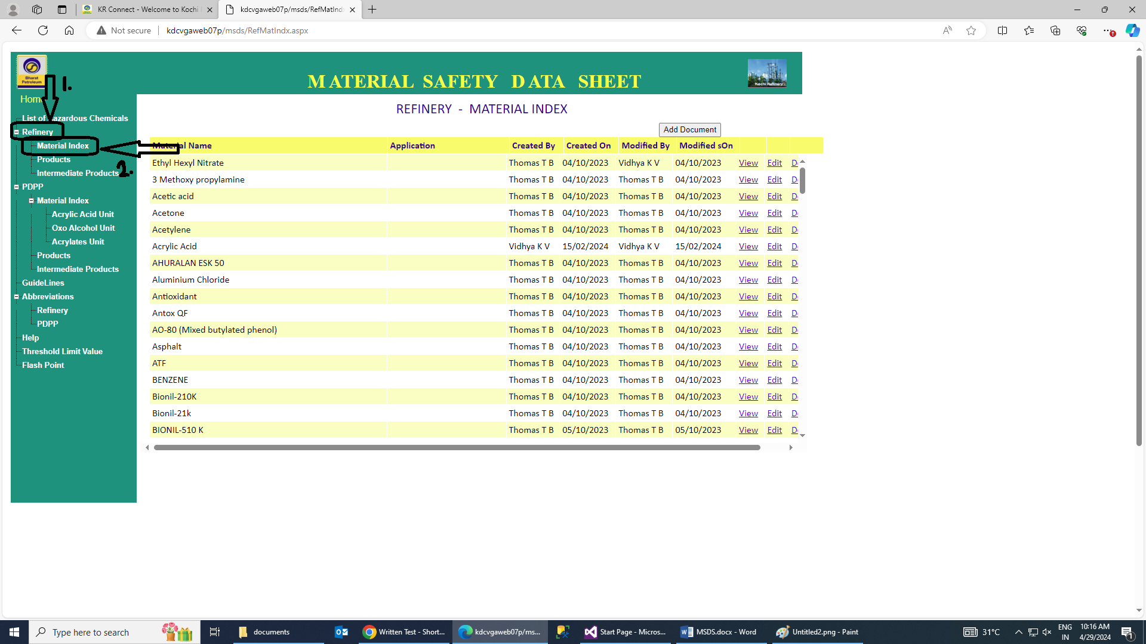

* **In material index there are many pdf file are given. We can add, view, edit and delete.**

For adding new document we have click on add document add fill the material data name

Add pdf file then upload.

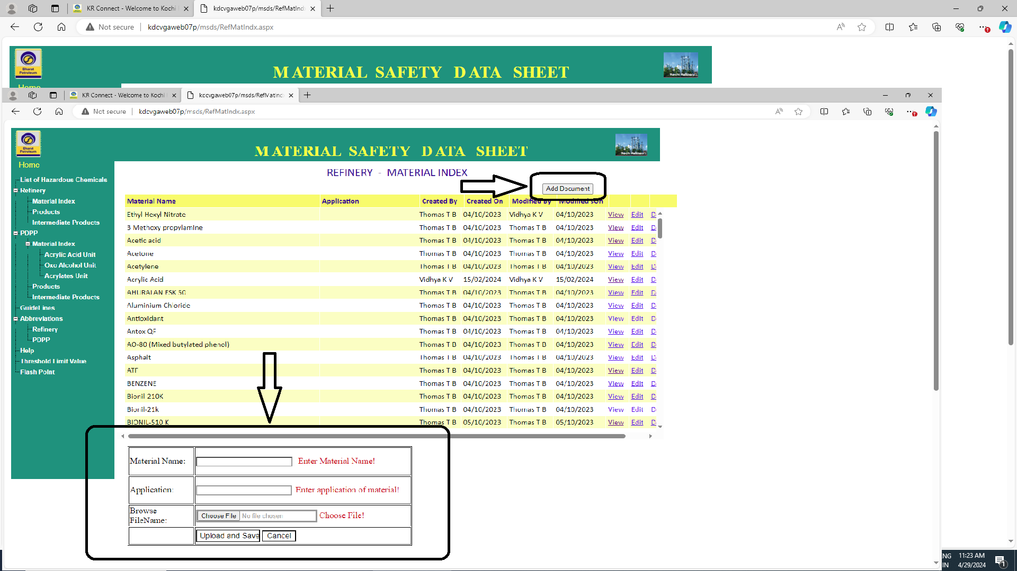

We can view the document by click on view.

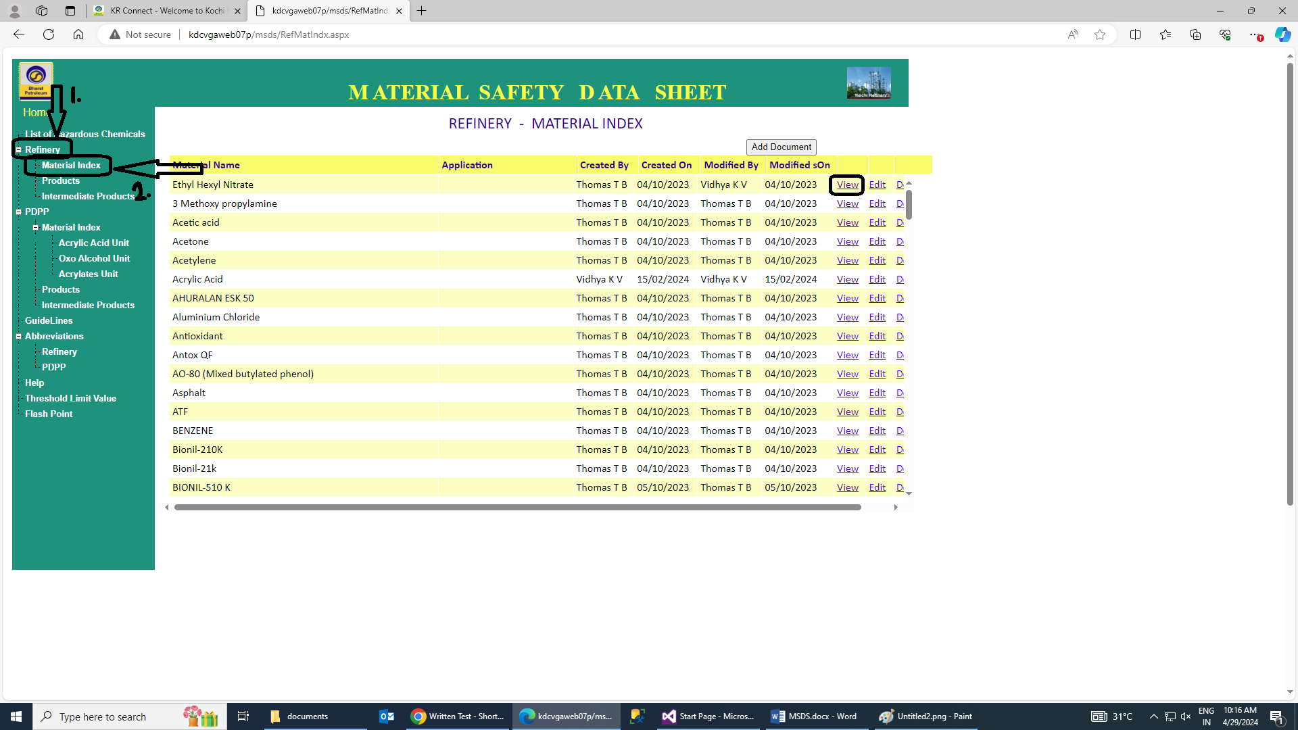

We can edit the document by click on edit.

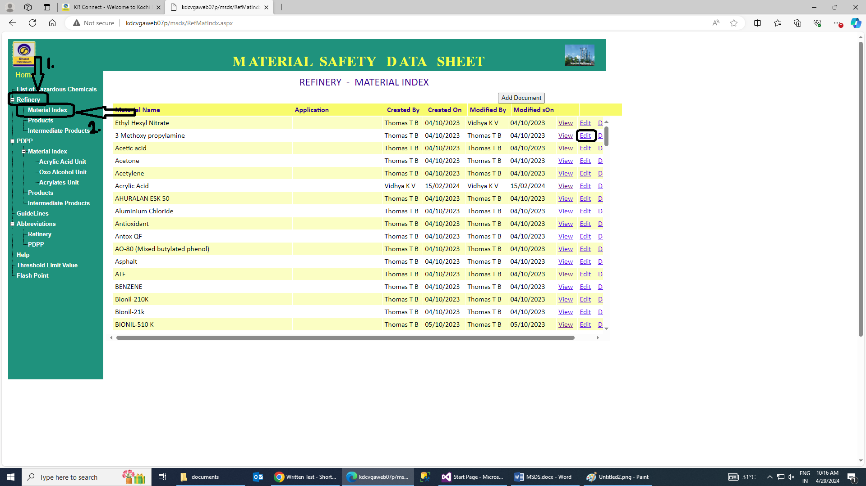

If we want to edit document in msds application then click on edit and edit document.

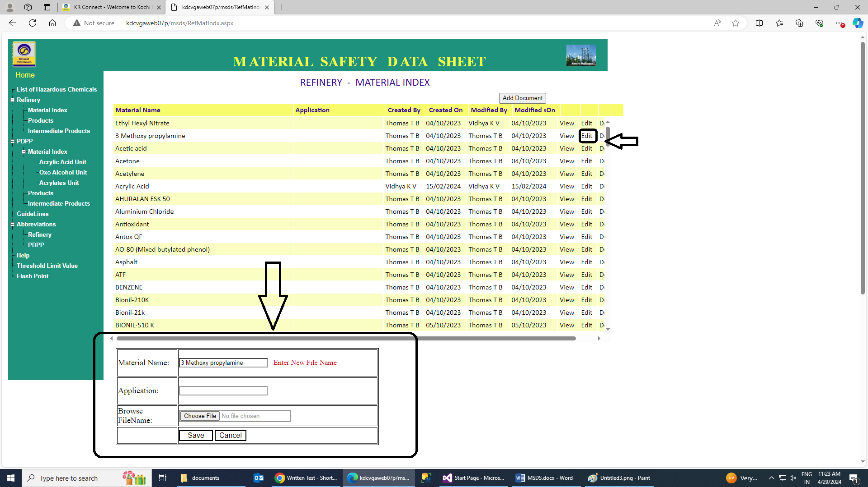

We can delete the document from msds application via click on delete .

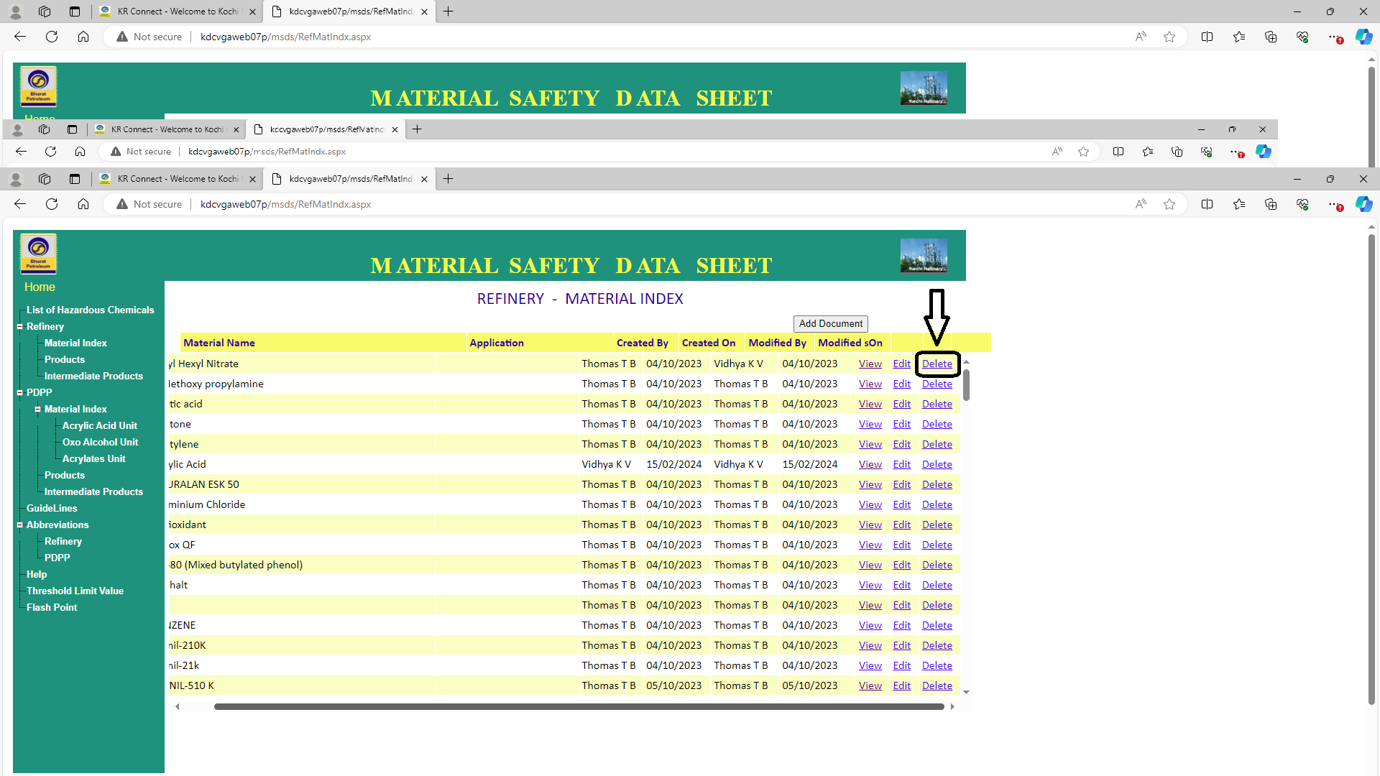

**PRODUCTS**

In this whatever we have done in material index same like here we will have done means here also we will have to add products document and view products document and delete products document.

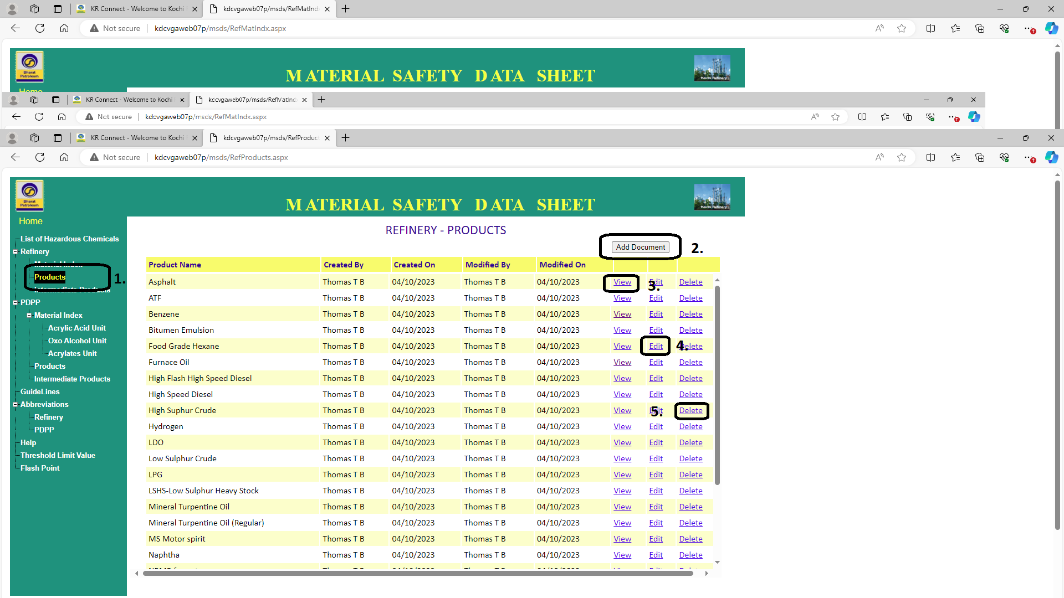

**PDPP**

1. **Material index**
2. ACRYLIC ACID UNIT
3. OXO  ALCOHOL  UNIT
4. ACRYLATES UNIT
5. **PRODUCTS**
6. **INTERMIDATE PRODUCTS**

**ACRYLIC ACID UNIT:**

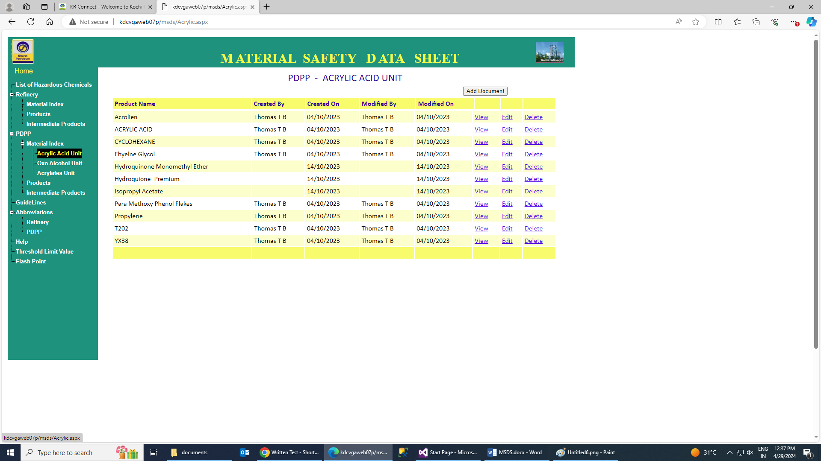

**OXO  ALCOHOL  UNIT:**

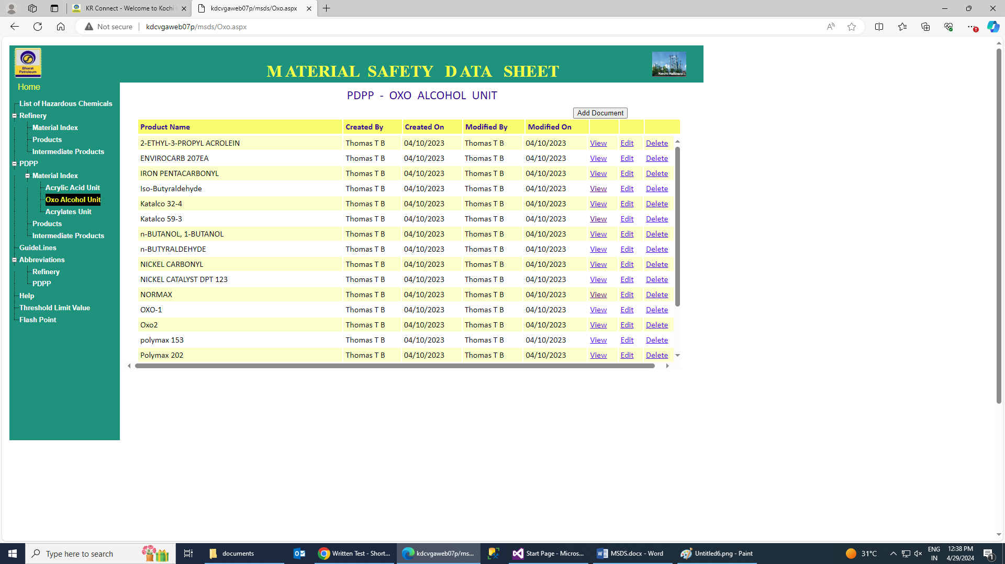

**ACRYLATES UNIT:**

